

**ARTIFICIAL INTELLIGENCE RECOMMENDATION SYSTEM FOR CANCER REHABILITATION SCHEME**

**A PROJECT REPORT**

***Submitted by***

**S.NIVETHANARAYANI [REGISTER NO:211417104173]**

**PALAGIRI VAISHNAVI [REGISTER NO:211417104177]**

**RAMYA PRABA [REGISTER NO:211417104221]**

***in partial fulfillment for the award of the degree***

***of***

**BACHELOR OF ENGINEERING**

**IN**

**COMPUTER SCIENCE AND ENGINEERING**

**PANIMALAR ENGINEERING COLLEGE, CHENNAI-600123**

**ANNA UNIVERSITY: CHENNAI 600 025**

**APRIL 2021**

**BONAFIDE CERTIFICATE**

Certified that this project report **“ARTIFICIAL INTELLIGENCE RECOMMENDATION SYSTEM FOR CANCER REHABILITATION SCHEME”** is the bonafide work of  **“PALAGIRI VAISHNAVI (211417104177), RAMYA PRABA (211417104221), S.NIVETHANARAYANI (211417104173)”** who carried out the project work under my supervision.

**SIGNATURE SIGNATURE**

**Dr.S.MURUGAVALLI,M.E.,Ph.D., Mrs.P.VIJAYALAKSHMI**

**HEAD OF THE DEPARTMENT SUPERVISOR**

**ASSOCIATE PROFESSOR**

DEPARTMENT OF CSE, DEPARTMENT OF CSE,

PANIMALAR ENGINEERING COLLEGE, PANIMALARENGINEERINGCOLLEGE, NAZARATHPETTAI, NAZARATHPETTAI,

POONAMALLEE, POONAMALLEE,

CHENNAI-600 123. CHENNAI-600 123.

Certified that the above candidates were examined in the Anna University Project Viva-Voice Examination held on...........................

**INTERNAL EXAMINER EXTERNAL EXAMINER**

**ACKNOWLEDGEMENT**

We express our deep gratitude to our respected Secretary and Correspondent **Dr.P.CHINNADURAI, M.A., Ph.D.** for his kind words and enthusiastic motivation, which inspired us a lot in completing this project.

We would like to extend our heartfelt and sincere thanks to our Directors **Tmt.C.VIJAYARAJESWARI**, **Thiru.C.SAKTHIKUMAR,M.E., - Ph.D** and **Tmt. SARANYASREE SAKTHIKUMAR B.E.,M.B.A.,** for providing us with the necessary facilities for completion of this project.

We also express our gratitude to our Principal **Dr.K.Mani, M.E., Ph.D.** for his timely concern and encouragement provided to us throughout the course.

We thank the HOD of CSE Department, **Dr. S.MURUGAVALLI , M.E.,Ph.D.,** for the support extended throughout the project.

We would like to thank my **Mrs.P.VIJAYALAKSHMI** and all the faculty members of the Department of CSE for their advice and suggestions for the successful completion of the project.

We would like to thank **god** for showering his blessing on us and we also thank our **parents** much for their support both emotional and financial over the years.

**S.NIVETHANARAYANI**

**PALAGIRI VAISHNAVI**

**RAMYA PRABA**

**ABSTRACT**

Cancer is the most difficult problem in the field of medicine, and its postoperative recovery has become the most concerning problem for cancer patients. Magnetic resonance imaging (MRI) is a widely used imaging technique to assess brain tumours, but the large amount of data produced by MRI needs manual segmentation in a reasonable time, limiting the use of precise quantitative measurements in the clinical practice. So, automatic and reliable segmentation methods are required. Automatic segmentation is a challenging problem in which manual detection and segmentation of brain tumors using brain MRI scan forms a large part of human intervention for detection and segmentation taken per patient, is both tedious and has huge internal and external observer detection and segmentation variability. Hence there is high demand for an efficient and automatic brain tumour detection and segmentation using brain MR images to overcome errors in manual segmentation. In Practice, the system uses HSI (Hyperspectral Imaging) to detect cancer cells. It is difficult to eliminate the ambiguities in MRI Brain samples. To overcome this difficulty, we are developing a system which detects the location of cancer cells through MR Images and also suggests effective treatment like medications, vaccines etc. to physicians.

.

**TABLE OF CONTENTS**

|  |  |  |
| --- | --- | --- |
| **CHAPTER NO.** | **TITLE** | **PAGE NO.** |
|  | **ABSTRACT** | iv |
|  | **LIST OF FIGURES** | vii |
| **1.** | **INTRODUCTION** | 10 |
|  | 1.1 Overview | 10 |
|  | 1.2 Problem Definition | 13 |
| **2.** | **LITERATURE SURVEY** | 14 |
| **3.** | **SYSTEM ANALYSIS** | 19 |
|  | 3.1 Existing System | 19 |
|  | 3.2 Proposed system | 20 |
|  | 3.3 Technology Stack | 20 |
| **4.** | **SYSTEM DESIGN** | 32 |
|  | 4.1 UML Diagram | 32 |
| **5.** | **SYSTEM ARCHITECTURE** | 38 |
|  | 5.1 Architecture Overview | 38 |
|  | 5.2 Dataset | 39 |
|  | 5.3 System Module | 40 |
|  | 5.4 Program Design Language | 47 |
| **6.** | **SYSTEM IMPLEMENTATION** | 49 |
| **7.** | **SYSTEM TESTING** | 63 |
|  | 7.1 Testing Techniques | 63 |
|  | 7.2 Performance Analysis | 64 |
| **8.** | **CONCLUSION** | 66 |
|  | 8.1 Conclusion and Future Enhancements | 66 |
|  | **APPENDICES** | 67 |
|  | A.1 Sample Screenshots | 67 |
|  | A.2 Publications | 72 |
|  | **REFERENCES** | 78 |

**LIST OF FIGURES**

|  |  |  |
| --- | --- | --- |
| **FIG NO.** | **TITLE** | **PAGE NO.** |
| 1.1.A | Example of brain image a and b with tumor | 11 |
| 1.1.B | Different techniques of Brain tumor imaging | 12 |
| 3.4.A | Data Points | 25 |
| 4.1.A | Use Case Diagram | 33 |
| 4.1.B | Sequence Diagram | 34 |
| 4.1.C | Activity Diagram | 35 |
| 4.1.D | Class Diagram | 36 |
| 5.1.A | System Architecture | 39 |
| 5.2.A | Non-Tumor Dataset | 40 |
| 5.2.B | Tumor Dataset | 40 |
| 5.3.2.A | Data Preprocessing | 41 |
| 5.3.2.B | Segmentation | 42 |
| 5.3.2.C | Extracted tumor | 43 |
| 5.3.2.D | Classification Using CNN | 44 |
| 5.3.2.E | Surgery Treatment | 45 |
| 5.3.2.F | Zoomed Surgery | 45 |
| 5.3.2.G | Before & After Treatment | 45 |
| 5.3.2.H | Radiation Therapy Treatment | 45 |
| 5.3.2.I | Chemotherapy Treatment | 46 |
| 5.3.2.J | Physical Therapy (walking after treatment) | 46 |
| 5.3.2.K | Day-to-day Activities after treatment | 46 |
| 5.3.2.L | Speech Therapy after treatment | 47 |
| 5.3.2.M | Recovering back to thinking capability after treatment | 47 |
| 5.4.1.A | CNN Layers | 48 |
| 7.2.A | Performance Graph on various classifier | 64 |
| 7.2.B | Evaluation Metrics on various Neural Networks | 65 |
| A.1.1 | Opening Command Prompt Window | 67 |
| A.1.2 | Type the path in cmd to open demo page | 67 |
| A.1.3 | Opened demo page and click browse button | 68 |
| A.1.4 | Selecting any one of the MRI brain image | 68 |
| A.1.5 | Upload the selected MRI Brain image | 69 |
| A.1.6 | Click detect to detect tumor in brain (Tumor detected image) | 69 |
| A.1.7 | Click view to see the tumour | 70 |
| A.1.8 | Segmented Brain Tumour | 70 |
| A.1.9 | Treatment Suggestion | 71 |

**CHAPTER 1**

**INTRODUCTION**

**1.1 OVERVIEW**

Cancer is a group of diseases characterized by the uncontrollable growth and rapid spread of abnormal cells which damages the nearby healthy tissues of brain. If the spread is not controlled, it can result in death. And also, not all tumors are cancer but all cancers are tumor. Brain tumor was the most common cancer in worldwide, contributing 2,093,876 of the total number of new cases diagnosed in 2020. This can be made faster and more accurate. In this study we propose machine learning strategies to improve cancer characterization. Inspired by learning from CNN approaches. Only about 4 to 5 percent of all cancers are genetically inherited, or hereditary. It’s rare for a brain tumor to be genetically inherited. Symptoms of brain tumors depend on the location and size of the tumor. Some tumors cause direct damage by invading brain tissue and some tumors cause pressure on the surrounding brain. You’ll have noticeable symptoms when a growing tumor is putting pressure on your brain tissue.

Tumor is categorized into Benign and Malignant.

* Benign - has non-cancerous characteristic.
* Malignant - has cancerous characteristic.

Pathology base categorization and different brain images which are affected by

tumor at different location are given below:-

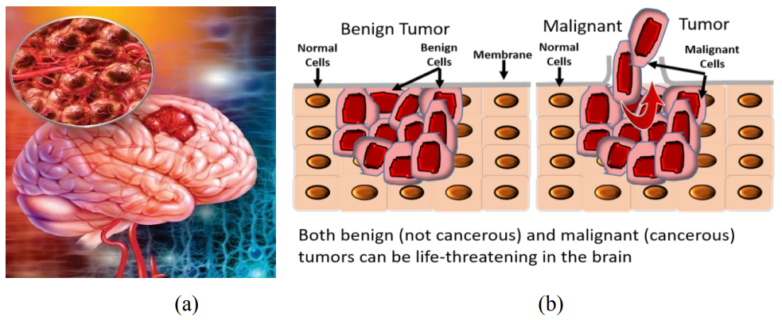 **FIGURE 1.1.A EXAMPLE OF BRAIN IMAGE (a) AND (b) WITH TUMOR**

**Magnetic Resonance Imaging (MRI)** is technique which uses the radio frequency signals to get the image of brain. This imaging technique is our focusing technique. MRI scans play an essential role in the screening and diagnosis of brain tumor. The wide adoption of Brain tumor screening is expected to benefit millions of people. However, millions of MRI scan images obtained from patients constitute a heavy workload for radiologists. To stimulate the development of machine learning models for automated MRI diagnosis, the BRATS17 provided labeled MRI brain images from 1397 patients and awarded $1 million in prizes to the best algorithms for automated brain cancer diagnosis, which is the largest machine learning challenge on medical imaging to date. In response, 1972 teams worldwide have participated and 394 teams have completed all phases of the competition, making it the largest health care–related brats17 contest. This provides a unique opportunity to study the robustness of medical machine learning models and compare the performance of various strategies for processing and classifying MR images at scale. Due to the improved performance of machine learning algorithms for radiology diagnosis, some developers have sought commercialization of their models. However, given the divergent software platforms, packages, and patches employed by different teams, their results were not easily reproducible. The difficulty in reusing the state-of-the-art models and reproducing the diagnostic performance markedly hindered further validation and applications. we implemented a Graphical user interface (GUI) which takes MRI Images as input and it pre-processes the data and detects the brain tumor whether it is present or not, if so it locates the tumor cell and the output will be the treatment suggestion for the detected tumor which will also be a benefit to the physician In Charge. This project is developed as an interface which is very user-friendly.

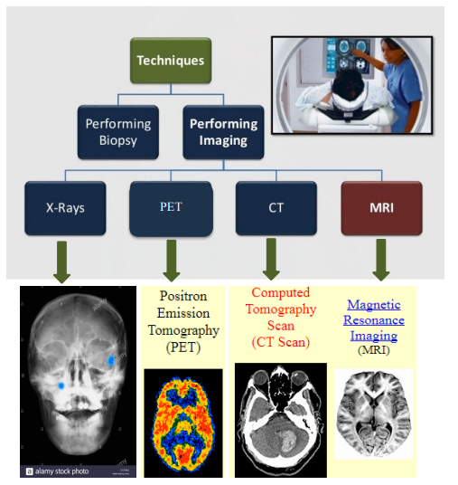

**FIGURE 1.1.B DIFFERENT TECHNIQUES OF BRAIN TUMOR IMAGING**

**1.2 PROBLEM DEFINITION**

Cancer is the most difficult problem in the field of medicine, and its postoperative recovery has become the most concerning problem for cancer patients. In the field of medical image processing, brain tumor detection and segmentation using MRI Scan has become one of the most important and challenging research areas . Magnetic resonance imaging (MRI) is a widely used imaging technique to assess these tumors, but the large amount of data produced by MRI needs manual segmentation in a reasonable time, limiting the use of precise quantitative measurements in the clinical practice. So, automatic and reliable segmentation methods are required.Automatic segmentation is a challenging problem in which manual detection and segmentation of brain tumors using brain MRI scan forms a large part of human intervention for detection and segmentation taken per patient, is both tedious and has huge internal and external observer detection and segmentation variability. Hence there is high demand for an efficient and automatic brain tumor detection and segmentation using brain MR images to overcome errors in manual segmentation. In Practice,the system uses HSI (Hyper Spectral Imaging) to detect cancer cells.It is difficult to eliminate the ambiguities of matching spectral profiles with biological samples and therefore the presence of fundamental non-uniqueness is another limitation of HSI.To overcome this difficulty, develop a system which detects the location of cancer cells through MR Images and also suggests some effective treatment like medications ,vaccines etc.. to physician.

**CHAPTER 2**

**LITERATURE SURVEY**

**2.1 A survey on Brain tumor detection techniques for MR images**

**Year:** 2020

**Author:** Prabhojot Kaur Chahal, Shreelekha Pandey & Shivani Goel

**Concept:** One of the most crucial tasks in any brain tumor detection system is the isolation of abnormal tissues from normal brain tissues. Interestingly, domain of brain tumor analysis has effectively utilized the concepts of medical image processing, particularly on MR images, to automate the core steps, i.e. extraction, segmentation, classification for proximate detection of tumor. Research is more inclined towards MR for its non-invasive imaging properties. Computer aided diagnosis or detection systems are becoming challenging and are still an open problem due to variability in shapes, areas, and sizes of tumor. The past works of many researchers under medical image processing and soft computing have made noteworthy review analysis on automatic brain tumor detection techniques focusing segmentation as well as classification and their combinations. In the manuscript, various brain tumor detection techniques for MR images are reviewed along with the strengths and difficulties encountered in each to detect various brain tumor types. The current segmentation, classification and detection techniques are also conferred emphasizing on the pros and cons of the medical imaging approaches in each modality. The survey presented here aims to help the researchers to derive the essential characteristics of brain tumor types and identifies various segmentation/classification techniques which are successful for detection of a range of brain diseases. The manuscript covers most relevant strategies, methods, their working rules, preferences, constraints, and their future snags on MR image brain tumor detection. An attempt to summarize the current state-of-art with respect to different tumor types would help researchers in exploring future directions.

**Merits:** Help the researchers to derive the essential characteristics of brain tumor types and identify various segmentation/classification techniques.

**Demerits:** MR Images are reviewed with difficulties encountered in each to detect various brain tumor types.

**2.2 BRAMSIT: A Database Brain tumor diagnosis and detection**

**Year:** 2020

**Author:** R.Tamilselvi, A.Nagaraj, M.Parisa Beham, M.Bharkavi Sandhiya

**Concept:** MRI is the most frequently used imaging technique to detect brain tumor. The brain is composed of nerve cells and supportive tissues such as glial cells and meninges. A brain tumor is a collection, or mass, of the brain in abnormal cells. Primary brain tumors can be either malignant or benign. A primary brain tumor is a tumor located in the brain tissue. New technologies in supplement to existing imaging modalities improve brain tumor screening. Most brain tumor databases are not publicly available. BRAMSIT is a resource for possible use by the MRI image analysis research community. The projected MRI database is a termed BRAMSIT, characterized by an attempt to offer a group of normal and malignant brain tumor images. The details such as age, and the MRI axial position (i.e., trans-axial, coronal and sagittal) of the patient are interpreted in the database.

**Merits:** Provide a set of MRI scan images consisting of normal, abnormal along with its ground truth images of different axial position.

**Demerits:** Wrong detection of tumor could be explored by small experiments,for example each method have some kind of threshold value if the right threshold is not selected then probably the detection result would be wrong.

**2.3 Development of automated  brain tumor detection using MRI Images**

**Year:** 2019

**Author:** T.M.Shahriar sazzad, K.M.Tanzibul Ahmmed,Misbah UI Hoque,Mahmuda Rahman

**Concept:** A tumor cell is a form of cell that develops out of control of the ordinary forces and standardizes growth. Brain tumor is one of the major reasons for human death every year. Around 50% of brain tumor diagnosed patient die with primary brain tumors each year in the United States. Electronic modalities are used to diagnose brain tumors. Among all electronic modalities, Magnetic Resonance Imaging (MRI) is one of the most used and popular for brain tumor diagnosis. In this research study, an automated approach has been proposed where MRI gray-scale images were incorporated for brain tumor detection. This study proposed an automated approach that includes enhancement at the initial stage to minimize gray-scale color variations. Filter operation was used to remove unwanted noises as much as possible to assist better segmentation. As this study test grayscale images therefore; threshold based OTSU segmentation was used instead of color segmentation. Finally, pathology experts provided

feature information was used to identify the region of interests (brain tumor region). The experimental results showed that the proposed approach was able to perform better results compared to existing available approaches in terms of accuracy while maintaining the pathology experts' acceptable accuracy rate.

**Merits:** The modalities of brain images are stated with illustrations and properly reviewed.

**Demerits:** Large gap between radiologist and automated brain tumor detection persons due to the incomplete process flow between them.

**2.4 Tumor detection and classification of brain MRI image using different wavelet transforms and support vector machines**

**Year:** 2019

**Author:** Mircea Gurbina, Mihaela Lascu, Dan Lascu

**Concept:** Brain tumor is one of the disease types that attacks the brain in the form of clots. There is a way to see brain tumor in detail required by an MRI image. There is difficulty in distinguishing brain tumor tissue from normal tissue because of the similar color. Brain tumor must be analyzed accurately. The solution for analyze brain tumor is doing segmentation. Brain tumor segmentation is done to separate brain tumor tissue from other tissues such as fat, edema, normal brain tissue and cerebrospinal fluid to overcome this difficulty, The MRI image must be maintained at the edge of the image first with the median filtering. Then the tumor segmentation process requires a thresholding method which is then iterated to take the largest area. The brain segmentation is done by giving a mark on the area of the brain and areas outside the brain using watershed method then clearing skull with cropping method. In this study, 14 brain tumor MRI images are used. The segmentation results are compared brain tumors area and brain tissues area. This system obtained the calculation of tumor area has an average error of 10%.

**Merits:** This paper put forward an analytical course of action for the recognition of brain tumors (BT).

**Demerits:** Difficult to isolate heterogeneous cancer cells Possibility to isolate normal stem cells.

**2.5 Brain tumor segmentation to calculate percentage tumor using MRI**

**Year:** 2018

**Author:** Annisa Wulandari, Riyanto Sigit, Mochamad Mobed Bachtiar

**Concept:** The brain is one of the most complex organs in the human body that works with billions of cells. A cerebral tumor occurs when there is an uncontrolled division of cells that form an abnormal group of cells around or within the brain. This cell group can affect the normal functioning of brain activity and can destroy healthy cells. Brain tumors are classified as benign or low-grade (grade 1 and 2) and malignant tumors or high-grade (grade 3 and 4). The proposed methodology aims to differentiate between normal brain and tumor brain (benign or malign). The study of some types of brain tumors such as metastatic bronchogenic carcinoma tumors, glioblastoma and sarcoma are performed using brain magnetic resonance imaging (MRI). The detection and classification of MRI brain tumors are implemented using different wavelet transforms and support vector machines. Accurate and automated classification of MRI brain images is extremely important for medical analysis and interpretation.

**Merits:** Brain tumors which are segmented to calculate the area of the tumor and the percentage of area.

**Demerits:** Not good for soft tissues (melanoma)

**CHAPTER 3**

**SYSTEM ANALYSIS**

**3.1 EXISTING SYSTEM**

Based on the advantages of Internet of things, this paper focuses on the research of intelligent recommendation model for cancer patients’ rehabilitation, and designs a user-friendly intelligent recommendation system of cancer rehabilitation scheme. In view of the uncertainty of the cause and time of recurrence of cancer patients, the convolutional neural network algorithm was used to predict both of them. The prediction results of the model showed that the prediction accuracy was high, reaching 92%. To solve the problem of the optimal nutrition program for the rehabilitation of cancer patients, we took the recurrence time as the objective function, and established the recommendation model of the optimal nutrition support program for the rehabilitation by using BAS algorithm. Finally, under the framework of Internet of things technology, the intelligent recommendation model of cancer rehabilitation prediction model and nutrition support program was integrated to realize the recommendation system of intelligent recommendation of rehabilitation nutrition support program for cancer rehabilitation patients according to their different characteristics. After the system simulation experiment, it was found that under the condition that the predicted recurrence location was almost unchanged (49% of simulation results and 50% of actual results), the nutritional support scheme recommended by the intelligent recommendation system could extend the postoperative recurrence time of patients by more than 95%. This recommendation system can help doctors select personalized nutrition and rehabilitation programs suitable for patients in the later stage of rehabilitation treatment according to different cancer patients, and has certain guiding significance for the field of cancer rehabilitation.

**3.2 PROPOSED SYSTEM**

Awareness of cancer patients and their families, health care providers, and specialized cancer centers is achieved through access to up-to-date information about various items. Today, intelligent information technology systems have an important role in the awareness of people. Therefore, a type of technology is required that is capable of learning people’s needs, interests and suggesting appropriate information accordingly. The emergence of information technology systems, like recommender systems, is a step towards selecting appropriate information. With modelling the preferences, interests, needs, requests, and behaviours of the users, recommender systems seek to predict the future preferences, needs, and behaviours of the users to recommend appropriate and helpful services accordingly. Recommender systems can be a suitable tool for the information management of cancer-related screenings, diagnoses, treatments, operations, and rehabilitation programs. Access to treatment and health recommendations from valid sources is an important component of the natural processes of human decision making. The aim of this collection is to introduce recommender systems to use in cancer-related issues.

**3.4 TECHNOLOGY STACK**

**3.4.1 HARDWARE REQUIREMENTS**

* Processor : Intel Pentium Dual Core 2.00GHz
* Hard disk : 500 GB
* RAM : 8 GB (minimum)

**3.4.2 SOFTWARE REQUIREMENTS**

* Python 3.6.4 Version
* Software tool : Anaconda Navigator (IDE)

**3.4.3 SOFTWARE SPECIFICATION**

**3.4.3.1 MACHINE LEARNING**

**Machine learning** (**ML**) is the study of computer [algorithms](https://en.wikipedia.org/wiki/Algorithm) that improve automatically through experience and by the use of data. It is seen as a part of [artificial intelligence](https://en.wikipedia.org/wiki/Artificial_intelligence). Machine learning algorithms build a model based on sample data, known as "[training data](https://en.wikipedia.org/wiki/Training_data)", in order to make predictions or decisions without being explicitly programmed to do so. Machine learning algorithms are used in a wide variety of applications, such as [email filtering](https://en.wikipedia.org/wiki/Email_filtering) and [computer vision](https://en.wikipedia.org/wiki/Computer_vision), where it is difficult or unfeasible to develop conventional algorithms to perform the needed tasks.

The types of machine learning algorithms are mainly divided into four categories:

* Supervised learning,
* Unsupervised learning,
* Semi-supervised learning,
* Reinforcement learning.

**3.4.3.1.1 SUPERVISED LEARNING**

Supervised learning algorithms build a mathematical model of a set of data that contains both the inputs and the desired outputs. The data is known as [training data](https://en.wikipedia.org/wiki/Training_data), and consists of a set of training examples. Each training example has one or more inputs and the desired output, also known as a supervisory signal. In the mathematical model, each training example is represented by an [array](https://en.wikipedia.org/wiki/Array_data_structure) or vector, sometimes called a feature vector, and the training data is represented by a [matrix](https://en.wikipedia.org/wiki/Matrix_(mathematics)). Through [iterative optimization](https://en.wikipedia.org/wiki/Mathematical_optimization#Computational_optimization_techniques) of an [objective function](https://en.wikipedia.org/wiki/Loss_function), supervised learning algorithms learn a function that can be used to predict the output associated with new inputs. An optimal function will allow the algorithm to correctly determine the output for inputs that were not a part of the training data. An algorithm that improves the accuracy of its outputs or predictions over time is said to have learned to perform that task.

**A. CLASSIFICATION**

As the name suggests, Classification is the task of “classifying things” into sub- categories. But, by a machine. If that doesn’t sound like much, imagine your computer being able to differentiate between you and a stranger. Between a potato and a tomato. Between an A grade and a F. In Machine Learning and Statistics, Classification is the problem of identifying to which of a set of categories (sub populations), a new observation belongs to, on the basis of a training set of data containing observations and whose categories membership is known.

**TYPES OF CLASSIFICATION**

Classification is of two types:

* Binary Classification
* Multi-class Classification

**Binary Classification**

When we have to categorize given data into 2 distinct classes. Example – On the basis of given health conditions of a person, we have to determine whether the person has a certain disease or not.

**Multi-class Classification**

The number of classes is more than two. For Example, On the basis of data about different species of flowers, we have to determine which specie does our observation belong to

* Binary and Multi-class Classification. Here x1 and x2 are our variables upon which the class is predicted. Suppose we have to predict whether a given patient has a certain disease or not, on the basis of 3 variables, called features. Which means there are two possible outcomes:

1. The patient has the said disease. Basically, a result labeled “Yes” or “True”.

2. The patient is disease free. A result labeled “No” or “False”.

This is a binary classification problem. We have a set of observations called training data set, which comprises of sample data with actual classification results. We train a model, called Classifier on this data set, and use that model to predict whether a certain patient will have the

1. X: pre-classified data, in the form of a N*M matrix. N is the no. of observations and M is the number of features

2. Y: An N-d vector corresponding to predicted classes for each of the N observations.

3. Feature Extraction: Extracting valuable information from input X using a series of transforms.

4. ML Model: The “Classifier” we’ll train.

5. y’: Labels predicted by the Classifier.

6. Quality Metric: Metric used for measuring the performance of the model.

7. ML Algorithm: The algorithm that is used to update weights w’, which update the model and “learns” iteratively.

Types of Classifiers (Algorithms)

There are various types of classifiers. Some of them are:

* Linear Classifiers: Logistic Regression
* Tree Based Classifiers: Decision Tree Classifier
* Support Vector Machines
* Artificial Neural Networks
* Bayesian Regression
* Gaussian Naive Bayes Classifiers
* Stochastic Gradient Descent (SGD) Classifier
* Ensemble Methods: Random Forests, AdaBoost, Bagging Classifier, Voting Classifier, Extra Trees Classifier

Practical Applications of Classification

* Google’s self-driving car uses deep learning enabled classification techniques which enables it to detect and classify obstacles.
* Spam E-mail filtering is one of the most widespread and well recognized uses of Classification techniques.
* Detecting Health Problems, Facial Recognition, Speech Recognition, Object Detection, Sentiment Analysis all use Classification at their core.

**B. REGRESSION**

A regression problem is when the output variable is a real or continuous value, such as “salary” or “weight”. Many different models can be used, the simplest is the linear regression. It tries to fit data with the best hyper-plane which goes through the points.

**3.4.3.1.2 UNSUPERVISED LEARNING**

Unsupervised learning algorithms take a set of data that contains only inputs, and find structure in the data, like grouping or clustering of data points. The algorithms, therefore, learn from test data that has not been labeled, classified or categorized. Instead of responding to feedback, unsupervised learning algorithms identify commonalities in the data and react based on the presence or absence of such commonalities in each new piece of data. A central application of unsupervised learning is in the field of [density estimation](https://en.wikipedia.org/wiki/Density_estimation) in [statistics](https://en.wikipedia.org/wiki/Statistics), such as finding the [probability density function](https://en.wikipedia.org/wiki/Probability_density_function). Though unsupervised learning encompasses other domains involving summarizing and explaining data features.

**A. CLUSTERING**

It is basically a type of unsupervised learning method. An unsupervised learning method is a method in which we draw references from datasets consisting of input data without labeled responses. Generally, it is used as a process to find meaningful structure, explanatory underlying processes, generative features, and groupings inherent in a set of examples. Clustering is the task of dividing the population or data points into a number of groups such that data points in the same groups are more similar to other data points in the same group and dissimilar to the data points in other groups. It is basically, a collection of objects on the basis of similarity and dissimilarity between them.For example, the data points in the graph below clustered together can be classified into one single group. We can distinguish the clusters, and we can identify that there are 3 clusters in the below picture.

**FIGURE 3.4.A DATA POINTS**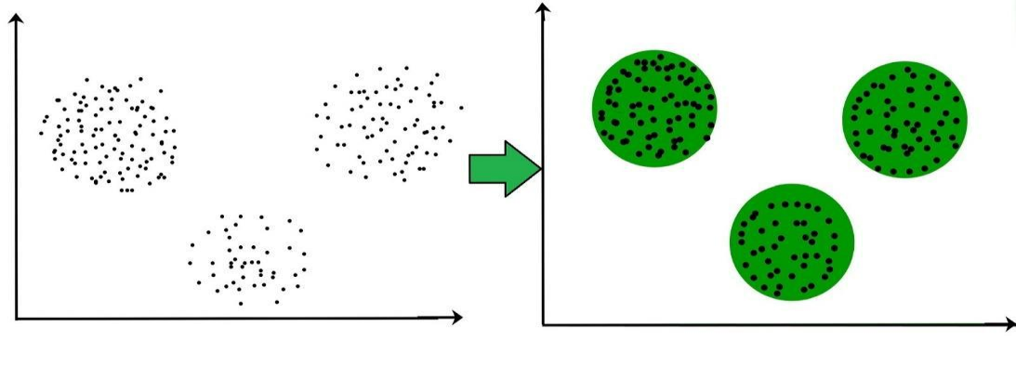

These data points are clustered by using the basic concept that the data point lies within the given constraint from the cluster center. Various distance methods and techniques are used for calculation of the outliers. Clustering is very much important as it determines the intrinsic grouping among the labeled data present. There are no criteria for a good clustering. It depends on the user, what is the criteria they may use which satisfy their need. For instance, we could be interested in finding representatives for homogeneous groups (data reduction), in finding “natural clusters” and describe their unknown properties (“natural” data types), in finding useful and suitable groupings (“useful” data classes) or in finding unusual data objects (outlier detection). This algorithm must make some assumptions which constitute the similarity of points and each assumption make different and equally valid clusters.

**CLUSTERING METHODS:**

1. **Density-Based Methods:** These methods consider the clusters as the dense region having some similarity and different from the lower dense region of the space. These methods have good accuracy and ability to merge two clusters. Example DBSCAN

(Density-Based Spatial Clustering of Applications with Noise) , OPTICS (Ordering Points to Identify Clustering Structure) etc.

1. **Hierarchical Based Methods:** The clusters formed in this method forms a tree type structure based on the hierarchy. New clusters are formed using the previously formed one. It is divided into two categories

* Agglomerative (bottom-up approach)
* Divisive (top-down approach)

1. **Partitioning Methods:** These methods partition the objects into k clusters and each partition forms one cluster. This method is used to optimize an objective criterion similarity function such as when the distance is a major parameter example K-means, CLARANS (Clustering Large Applications based upon randomized Search) etc.
2. **Grid-based Methods:** In this method the data space are formulated into a finite number of cells that form a grid-like structure. All the clustering operation done on these grids are fast and independent of the number of data objects example STING (Statistical Information Grid), wave cluster, CLIQUE (Clustering In Quest) etc.

Clustering Algorithms:

* K-Means Clustering.
* Mean-Shift Clustering for a single sliding window.
* The entire process of Mean-Shift Clustering.
* DBSCAN Smiley Face Clustering.
* EM Clustering using GMMs.
* Agglomerative Hierarchical Clustering.

**3.4.3.1.3 SEMI-SUPERVISED LEARNING**

Semi-supervised learning falls between [unsupervised learning](https://en.wikipedia.org/wiki/Unsupervised_learning) (without any labeled training data) and [supervised learning](https://en.wikipedia.org/wiki/Supervised_learning) (with completely labeled training data). Some of the training examples are missing training labels, yet many machine-learning researchers have found that unlabeled data, when used in conjunction with a small amount of labeled data, can produce a considerable improvement in learning accuracy.

**3.4.3.1.4 REINFORCEMENT LEARNING**

Reinforcement learning is an area of machine learning concerned with how [software agents](https://en.wikipedia.org/wiki/Software_agent) ought to take [actions](https://en.wikipedia.org/wiki/Action_selection) in an environment so as to maximize some notion of cumulative reward. Due to its generality, the field is studied in many other disciplines, such as [game theory](https://en.wikipedia.org/wiki/Game_theory), [control theory](https://en.wikipedia.org/wiki/Control_theory), [operations research](https://en.wikipedia.org/wiki/Operations_research), [information theory](https://en.wikipedia.org/wiki/Information_theory), [simulation-based optimization](https://en.wikipedia.org/wiki/Simulation-based_optimization), multi-agent systems, [swarm intelligence](https://en.wikipedia.org/wiki/Swarm_intelligence), [statistics](https://en.wikipedia.org/wiki/Statistics) and [genetic algorithms](https://en.wikipedia.org/wiki/Genetic_algorithm). In machine learning, the environment is typically represented as a [Markov decision process](https://en.wikipedia.org/wiki/Markov_decision_process) (MDP). Many reinforcement learning algorithms use [dynamic programming](https://en.wikipedia.org/wiki/Dynamic_programming) techniques. Reinforcement learning algorithms do not assume knowledge of an exact mathematical model of the MDP, and are used when exact models are infeasible. Reinforcement learning algorithms are used in autonomous vehicles or in learning to play a game against a human opponent.

**3.4.3.2 ANACONDA**

Anaconda is a free and open source distribution of the Python and R programming languages for data science and machine learning related applications (large-scale data processing, predictive analytics, scientific computing), that aims to simplify package management and deployment. Package versions are managed by the package management system conda.

Anaconda Distribution is used by over 6 million users, and it includes more than 250 popular data science packages suitable for Windows, Linux, and MacOS.

**3.4.3.3 PYTHON**

Python is a high-level programming language devised by Guido van Rossum & first released in 1991. It’s the most popular coding language used by software developers to build, control, manage and for testing. It is also an interpreter which executes Python programs. The python interpreter is called python.exe on Windows.

**Python Packages**

Packages or additional libraries help in scientific computing and computational modelling. In Python, the packages are not the part of the Python standard library. Few major packages are –

numpy (NUMeric Python): matrices and linear algebra

scipy (SCIentific Python): many numerical routines

matplotlib: (PLOTting LIBrary) creating plots of data

sympy (SYMbolic Python): symbolic computation

pytest (Python TESTing): a code testing framework

Together with a list of Python packages, tools like editors, Python distributions include the Python interpreter. Anaconda is one of several Python distributions. Anaconda is a new distribution of the Python and R data science package. It was formerly known as Continuum Analytics. Anaconda has more than 100 new packages.

This work environment, Anaconda is used for scientific computing, data science, statistical analysis, and machine learning. The latest version of Anaconda 5.0.1 is released in October 2017.The released version 5.0.1 addresses some minor bugs and adds useful features, such as updated R language support. All of these features weren’t available in the original 5.0.0 release.

This package manager is also an environment manager, a Python distribution, and a collection of open source packages and contains more than 1000 R and Python Data Science Packages.

**3.4.3.3.1 IPYTHON NOTEBOOKS**

IPython is a command shell for interactive computing in multiple programming languages, originally developed for the Python programming language, that offers introspection, rich media, shell syntax, tab completion, and history. IPython provides the following features:

* Interactive shells (terminal and Qt-based).
* A browser-based notebook interface with support for code, text, mathematical expressions, inline plots and other media.
* Support for interactive data visualization and use of GUI toolkits.
* Flexible, embeddable interpreters to load into one's own projects.
* Tools for parallel computing.

IPython is based on an architecture that provides parallel and distributed computing. IPython enables parallel applications to be developed, executed, debugged and monitored interactively. Hence, the I (Interactive) in IPython.[3]This architecture abstracts out parallelism, which enables IPython to support many different styles of parallelism [4]including: With the release of IPython 4.0, the parallel computing capabilities have been made optional and released under the ipyparallel python package.IPython frequently draw from SciPy stack[5] libraries like NumPy and SciPy, often installed alongside from one of many Scientific Python distributions. IPython provide integration some library of the SciPy stack like matplotlib, like inline graph when in used with the Jupyter notebook. Python libraries can implement IPython specific hooks to customize object Rich object display. SymPy for example implement rendering of Mathematical Expression as rendered LaTeX when used within IPython context.

**Other features:**

IPython also allows non-blocking interaction with Tkinter, PyGTK, PyQt/PySide and wxPython (the standard Python shell only allows interaction with Tkinter). IPython can interactively manage parallel computing clusters using asynchronous status call-backs and/or MPI. IPython can also be used as a system shell replacement. Its default behaviour is largely similar to Unix shells, but it allows customization and the flexibility of executing code in a live Python environment. Using IPython as a shell replacement is less common and it is now recommended to use Xonsh which provide most of the IPython feature with better shell integrations.

**CHAPTER 4**

**SYSTEM DESIGN**

In the software Development Life Cycle, the output of the system requirement analysis phase can be considered as an input to the system design phase. The architectural description of a System with details about its components, modules, interfaces and data is called System design.

**4.1 UML DIAGRAMS**

The UML has become the standard language used in Object-oriented analysis and design. It is widely used for modeling software systems. Through UML diagrams we specify and visualize various aspects of a System and its architecture.

**4.1.1 USE CASE DIAGRAM**

Use-Case diagrams helps to give the dynamic view of the system. Use case diagrams are a clear visualization of actors (the internal or external factors), their roles (use cases) and relationship amongst these actors and their roles.

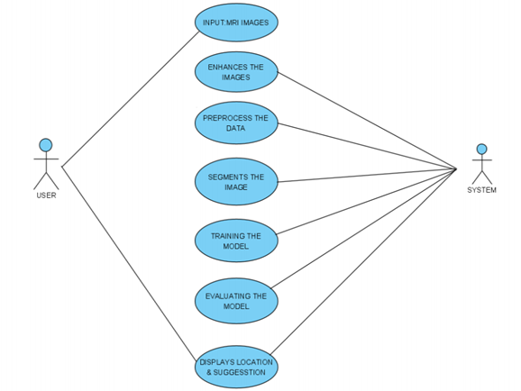

**FIGURE 4.1.A USE CASE DIAGRAM**

**DESCRIPTION :**

* In this system there are two actors which are the user and AI system.
* The user gives MRI images as input which are collected from the database to the system.
* The system will then do the process of preprocessing to improve quality of image, segmentation to separate out the tumor part.
* After processing of data, the very next task is training the model and then evaluating the performance of the model after training and validation.
* This system not only detects tumors in the brain but also displays treatment suggestions to the doctors.

**4.1.2 SEQUENCE DIAGRAM**

A sequence diagram simply depicts interaction between objects in a sequential order i.e. the order in which these interactions take place. Sequence diagrams describe how and in what order the objects in a system function.

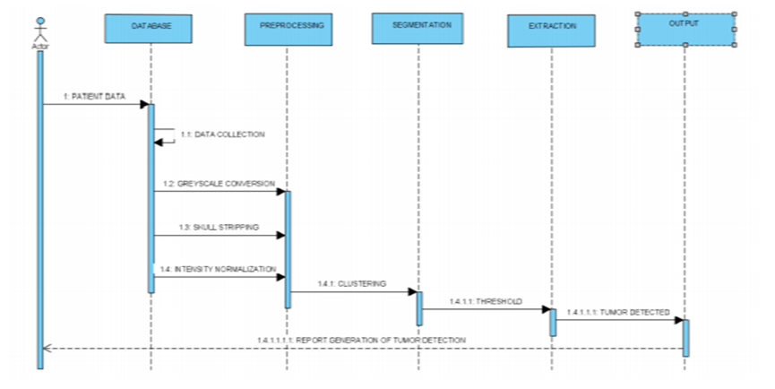

**FIGURE 4.1.B SEQUENCE DIAGRAM**

**DESCRIPTION :**

* Actor interact with database for patient data.
* The database which then collects data and moves to preprocessing, preprocessing to segmentation, segmentation to extraction and extraction to output which then generates a report of tumor detection to the actor.

**4.1.3 ACTIVITY DIAGRAM**

An activity diagram focuses on the condition of flow and the sequence in which it happens. We describe or depict what causes a particular event using an activity diagram. So, we use Activity Diagrams to illustrate the flow of control in a system.

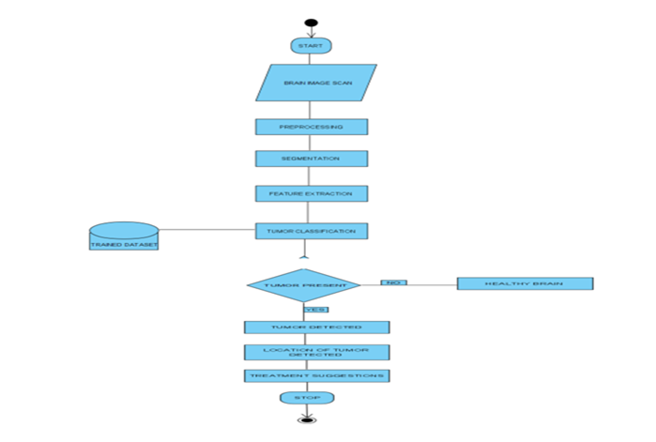

**FIGURE 4.1.C ACTIVITY DIAGRAM**

**DESCRIPTION :**

* Here, at first scan the brain image using a MRI imaging technique
* The initial step of image processing in MRI is image preprocessing to improve the image quality by removing unwanted data around the image .
* Then do segmentation using segmentation techniques and extracting the data from segmented part based on features like size, shape etc.
* Classification using CNN based on a trained dataset says whether the tumor is present or not.
* If no tumor, displays a healthy brain. If a tumor is present, display the tumor detected and give treatment suggestions for it.

**4.1.4 CLASS DIAGRAM**

Class diagram is a graphical representation of the static view of the system. It describes the design and structure of the system by displaying the system’s classes, their attributes, methods and relationships among objects.

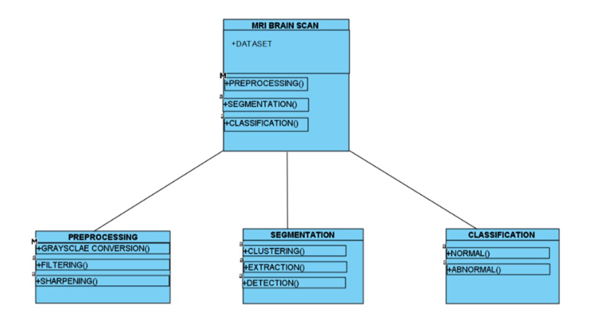

**FIGURE 4.1.D CLASS DIAGRAM**

**DESCRIPTION :**

* The class of MRI brain scan has a dataset as an attribute and the methods are preprocessing, segmentation and classification.
* The class MRI brain scan further extends its methods into sub-classes such as preprocessing, segmentation and classification.
* The preprocessing will do functions like grayscale conversion, filtering and sharpening. The segmentation will do functions like clustering, extraction and detection. The classification will do functions like classify the image into normal and abnormal using CNN.

**CHAPTER 5**

**SYSTEM ARCHITECTURE**

System architecture is the conceptual model that defines the structure, behaviour, and more views of a system. An architecture description is a formal description and representation of a system, organized in a way that supports reasoning about the structures and behaviour of the system.

**5.1 ARCHITECTURE OVERVIEW**

MR Brain Image is the input image which is taken from the dataset (database) for image processing. The image processing has three major steps are Data Pre-processing, Segmentation and Feature Extraction. The first step of image processing is Data pre-processing. Data preprocessing is the process of taking only the necessary data from the input MRI by removing unwanted data present in the MRI image and data pre-processing involves the functions like converting into grayscale image, apply different filtering methods to remove noise, image enhancement to improve the image quality. This will be converted into a suitable form on which further work can be performed. Next move to the segmentation process. This process will separate out the tumour region from the MRI image and segmentation involves the function of threshold-based segmentation. The threshold-based segmentation is the technique used by the segmentation process. This technique will detect and highlight the tumor region based on pixel intensity (high impressions). And then moves to the feature extraction process. This process will extract the features of segmented part like size, shape, tissue texture and location. After the basic operations of image processing on MRI image, the CNN algorithm will perform on processed image to classify into normal healthy brain or tumour brain. This classification is done by using the algorithm called CNN (Convolution Neural Network). The purpose of using CNN is the best for image recognition. And finally, treatment suggestions will be given to the physician if the tumour is identified in brain.

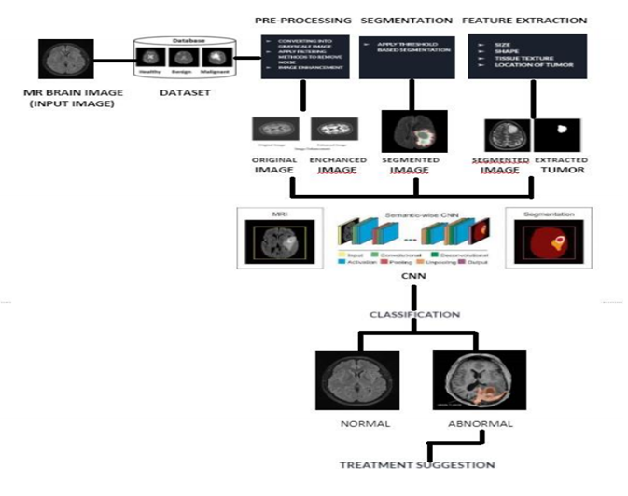

**FIGURE 5.1.A SYSTEM ARCHITECTURE**

**5.2 DATASET**

One of the major challenges of this project is to find the suitable dataset. Bio medical images are hard to find due to privacy issues. But the dataset we have used for this model was taken from Kaggle-Brats17. For our model we have taken 253 image samples which consist of 98 tumors and 155 non tumors. MR Images are taken as input in this system which are in jpeg or jpg,sss.

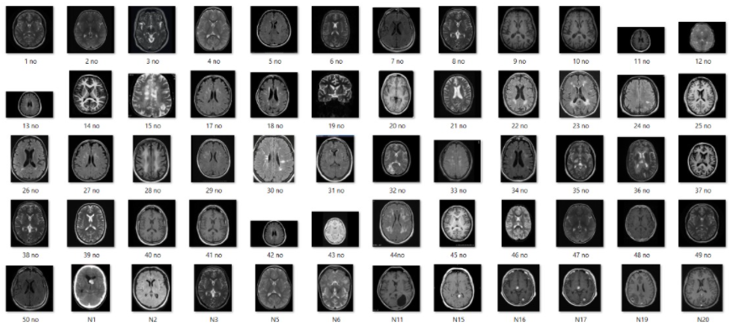 **FIGURE 5.2.A NON-TUMOR DATASET**

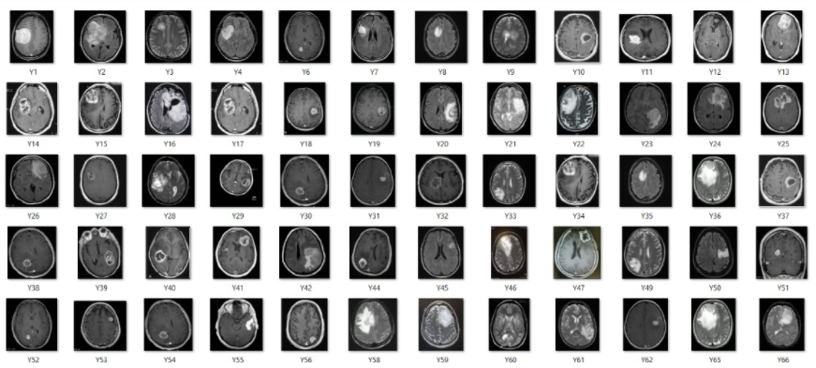

**FIGURE 5.2.B TUMOR DATASET**

**5.3 SYSTEM MODULE**

**5.3.1 MODULE**

* Data Pre-processing
* Segmentation
* Feature Extraction
* Classification
* Training and Testing
* Treatment Suggestion

**5.3.2 MODULE DESCRIPTION**

**DATA PREPROCESSING**

* Collecting the data is one task and making that data useful is an another vital task.
* Data collected from various means will be in an unorganized format and there may be lot of null values, in-valid data values and unwanted data.
* Cleaning all these data and replacing them with appropriate or approximate data and removing null and missing data and replacing them with some fixed alternate values are the basic steps in pre-processing of data.
* Even data collected may contain completely garbage values. It may not be in exact format or way that is meant to be.
* All such cases must be verified and replaced with alternate values to make data meaningful and useful for further processing. Data must be kept in an organized format.

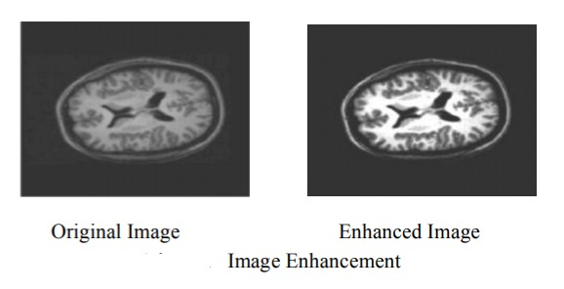

**FIGURE 5.3.2.A DATA PREPROCESSING**

**SEGMENTATION**

* Segmentation technique is to separate out tumor region from MRI image. Using segmentation, it is possible to identify objects, boundaries, location in an image.
* A lot of research has been carried out in the area of segmentation.
* In computer science, it is used for the dividing of digital images into multiple segments.
* It is used to achieve the goal to obtain the more meaningful and easier to analyze a image as it simply or change the image representation.
* There are many applications of segmentation in medical field like identify the diseases in MRI or CT scan images, to locate tumor.

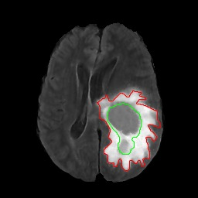

**FIGURE 5.3.2.B SEGMENTED IMAGE**

**FEATURE EXTRACTION**

* Feature extraction comes after the segmentation process to point us the exact tumor
* Feature extraction is the process of extracting the features of segmented brain tumor.
* It is a crucial task in case of brain tumor because of the complex structure of brain.
* Certain parameters are taken into account for feature extraction as size, shape, composition, location of image
* As per the result obtained from the feature extraction the classification of the tumor is done.

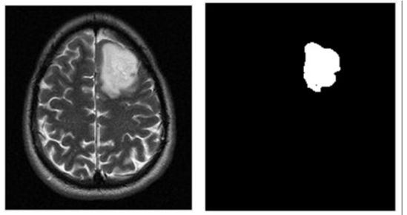

**FIGURE 5.3.2.C EXTRACTED TUMOR**

**CLASSIFICATION**

* Image classification is a process of classifying the items according to its type and pattern from the image in the dataset
* Image classification performs on image using CNN algorithm
* This CNN algorithm used to classify it into normal brain or tumor brain.
* For example, if we have a MRI brain image and we want to train our CNN on that image to classify it into “normal brain” or “tumor brain”.

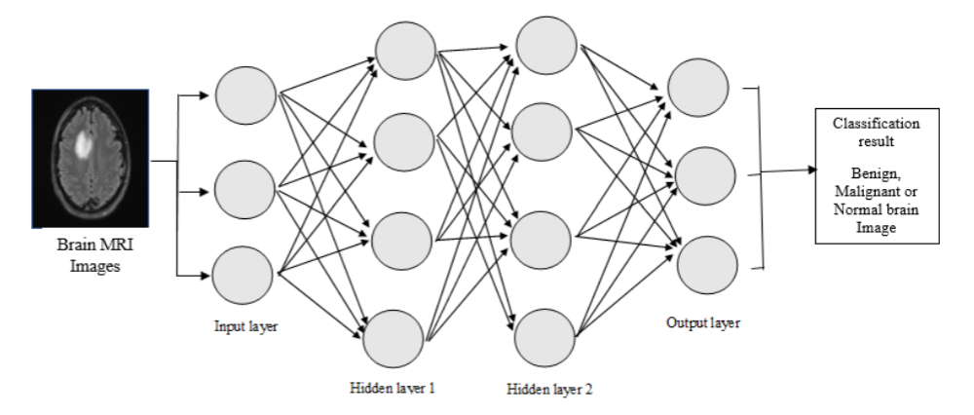

**FIGURE 5.3.2.D CLASSIFICATION USING CNN**

**TRAINING AND TESTING**

* Finally after processing of data and training, the very next task is obviously testing. This is where performance of the algorithm, quality of data, and required output all appears out.
* From the huge data set collected 90 percent of the data is utilized for training and 10 percent of the data is reserved for testing.
* Training as discussed before is the process of making the machine to learn and giving it the capability to make further predictions based on the training it took.
* Whereas testing means already having a predefined data set with output also previously labeled and the model is tested whether it is working properly or not and is giving the right prediction or not.
* If the maximum number of predictions are right then model will have a good accuracy percentage and is reliable to continue with otherwise better to change the model.

**TREATMENT SUGGESTION**

* Treatment suggestions include types of treatments that are the standard of care for a brain tumor. “Standard of Care” means the best treatments known.
* Treatment for a brain tumor depends on size, type and location of the tumor cells.
* Treatment includes surgery,radiation and chemotherapy.
* **Surgery -** If the tumor is located in a place that makes it accessible for an operation,the surgeon will work to remove the tumor cells as much as possible.

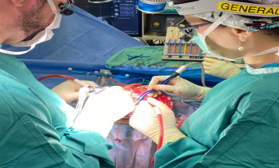 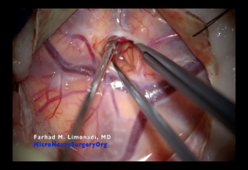 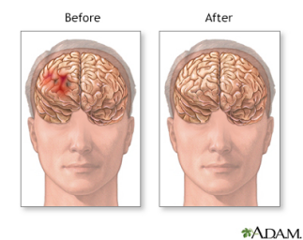

**FIGURE 5.3.2.E SURGERY FIGURE 5.3.2.F ZOOMED FIGURE 5.3.2.G BEFORE**

**TREATMENT SURGERY & AFTER TREATMENT**

**Radiation Therapy -** This therapy uses high energy beams like X-rays or protons to kill tumor cells.It may cause many side effects also.

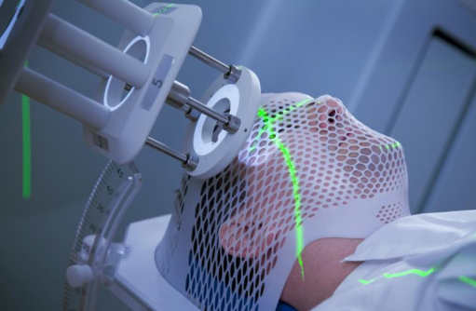

**FIGURE 5.3.2.H RADIATION THERAPY TREATMENT**

* **Chemotherapy -** Under this therapy,doctors use medications like drug called temozolomide(temodar) which is taken as a pill, vaccines etc.

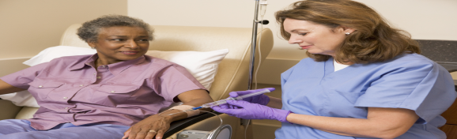

**FIGURE 5.3.2.I CHEMOTHERAPY TREATMENT**

**REHABILITATION AFTER TREATMENT**

* There is a need for rehabilitation because brain tumors can develop in parts of the brain that control motor skills,speech,vision and thinking.
* **Physical Therapy** to help you regain lost motor skills or muscle strength

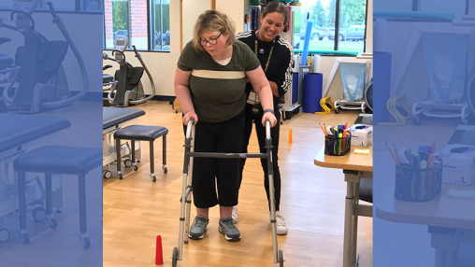

**FIGURE 5.3.2.J PHYSICAL THERAPY (WALKING AFTER TREATMENT)**

* **Occupational Therapy** to help you get back to your normal daily activities, including work, after a brain tumor or other illness

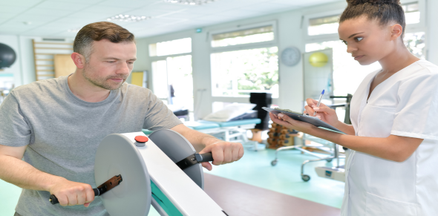

**FIGURE 5.3.2.K DAY-TO-DAY ACTIVITIES AFTER TREATMENT**

* **Speech Therapy** with specialists in speech difficulties (speech pathologists) to help if you have difficulty speaking

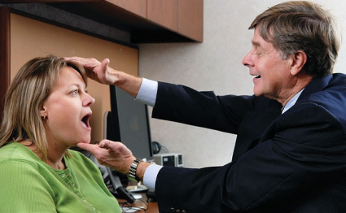

**FIGURE 5.3.2.L SPEECH THERAPY AFTER TREATMENT**

* **Tutoring for school-age children** to help kids cope with changes in their memory and thinking after a brain tumor



**FIGURE 5.3.2.M RECOVERING BACK TO THINKING CAPABILITY AFTER TREATMENT**

**5.4 PROGRAM DESIGN LANGUAGE**

**5.4.1 ALGORITHM – CNN (CONVOLUTION NEURAL NETWORK)**

Our program design language is the Algorithm type. Here we used algorithm is CNN (Convolution Neural Network). The purpose of using CNN is the best for image recognition.

* Convolution Neural Network (CNN) is a class of Deep learning algorithms.
* CNN is an algorithm that can take in an input image, assign importance (learnable weights and biases) to various aspects/objects in the image, and be able to differentiate one from the other.
* CNN works by extracting features from the image any CNN consists of the following:

a. The input layer which is a gray scale image.

b. The output layer which is a binary or multi-class labels.

c. Hidden layers consisting of convolution layers, RELU (rectified linear unit) layers, the pooling layers, and a fully connected Neural Network

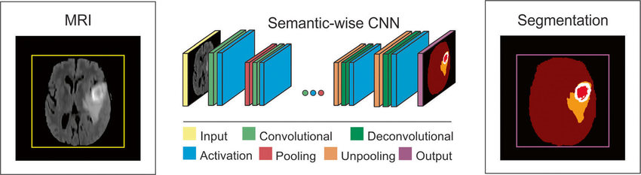

**FIGURE 5.4.1.A CNN LAYER**

**CHAPTER 6**

**SYSTEM IMPLEMENTATION**

DISPLAY:

import numpy as np

import cv2 as cv

class DisplayTumor:

curImg = 0

Img = 0

def readImage(self, img):

self.Img = np.array(img)

self.curImg = np.array(img)

gray = cv.cvtColor(np.array(img), cv.COLOR_BGR2GRAY)

self.ret, self.thresh = cv.threshold(gray, 0, 255, cv.THRESH_BINARY_INV + cv.THRESH_OTSU)

def getImage(self):

return self.curImg

# noise removal

def removeNoise(self):

self.kernel = np.ones((3, 3), np.uint8)

opening = cv.morphologyEx(self.thresh, cv.MORPH_OPEN, self.kernel, iterations=2)

self.curImg = opening

def displayTumor(self):

# sure background area

sure_bg = cv.dilate(self.curImg, self.kernel, iterations=3)

# Finding sure foreground area

dist_transform = cv.distanceTransform(self.curImg, cv.DIST_L2, 5)

ret, sure_fg = cv.threshold(dist_transform, 0.7 * dist_transform.max(), 255, 0)

# Find unknown region

sure_fg = np.uint8(sure_fg)

unknown = cv.subtract(sure_bg, sure_fg)

# Marker labelling

ret, markers = cv.connectedComponents(sure_fg)

# Add one to all labels so that sure background is not 0, but 1

markers = markers + 1

# Now mark the region of unknown with zero

markers[unknown == 255] = 0

markers = cv.watershed(self.Img, markers)

self.Img[markers == -1] = [255, 0, 0]

tumorImage = cv.cvtColor(self.Img, cv.COLOR_HSV2BGR)

self.curImg = tumorImage

FRAMES:

import tkinter

from PIL import ImageTk

from PIL import Image

class Frames:

xAxis = 0

yAxis = 0

MainWindow = 0

MainObj = 0

winFrame = object()

btnClose = object()

btnView = object()

image = object()

method = object()

callingObj = object()

labelImg = 0

def __init__(self, mainObj, MainWin, wWidth, wHeight, function, Object, xAxis=10, yAxis=10):

self.xAxis = xAxis

self.yAxis = yAxis

self.MainWindow = MainWin

self.MainObj = mainObj

self.MainWindow.title("Tumour Detection")

if (self.callingObj != 0):

self.callingObj = Object

if (function != 0):

self.method = function

global winFrame

self.winFrame = tkinter.Frame(self.MainWindow, width=wWidth, height=wHeight)

self.winFrame['borderwidth'] = 5

self.winFrame['relief'] = 'ridge'

self.winFrame.place(x=xAxis, y=yAxis)

self.btnClose = tkinter.Button(self.winFrame, text="Close", width=8,

command=lambda: self.quitProgram(self.MainWindow))

self.btnClose.place(x=1020, y=600)

self.btnView = tkinter.Button(self.winFrame, text="View", width=8, command=lambda: self.NextWindow(self.method))

self.btnView.place(x=900, y=600)

def setCallObject(self, obj):

self.callingObj = obj

def setMethod(self, function):

self.method = function

def quitProgram(self, window):

global MainWindow

self.MainWindow.destroy()

def getFrames(self):

global winFrame

return self.winFrame

def unhide(self):

self.winFrame.place(x=self.xAxis, y=self.yAxis)

def hide(self):

self.winFrame.place_forget()

def NextWindow(self, methodToExecute):

listWF = list(self.MainObj.listOfWinFrame)

if (self.method == 0 or self.callingObj == 0):

print("Calling Method or the Object from which Method is called is 0")

return

if (self.method != 1):

methodToExecute()

if (self.callingObj == self.MainObj.DT):

img = self.MainObj.DT.getImage()

else:

print("Error: No specified object for getImage() function")

jpgImg = Image.fromarray(img)

current = 0

for i in range(len(listWF)):

listWF[i].hide()

if (listWF[i] == self):

current = i

if (current == len(listWF) - 1):

listWF[current].unhide()

listWF[current].readImage(jpgImg)

listWF[current].displayImage()

self.btnView['state'] = 'disable'

else:

listWF[current + 1].unhide()

listWF[current + 1].readImage(jpgImg)

listWF[current + 1].displayImage()

print("Step 22Extraction complete")

print("\nTreatment ")

print("\nTreatment for a brain tumor depends on the type,size and location of the tumor, as well as your overall health and your preferences")

print("\nSurgery")

print("\nIf the brain tumor is located in a place that makes it accessible for an operation, your surgeon will work to remove as much of the brain tumor as possible.")

print("\nRadiation therapy")

print("\nRadiation therapy uses high-energy beams, such as X-rays or protons, to kill tumor cells.")

print("Radiation therapy can come from a machine outside your body (external beam radiation), or, in very rare cases, radiation can be placed inside your body close to your brain tumor (brachytherapy) ")

print("\nChemotherapy")

print("\nChemotherapy uses drugs to kill tumor cells.")

print("\nChemotherapy drugs can be taken orally in pill form or injected into a vein (intravenously).")

print("\nThe chemotherapy drug used most often to treat brain tumors is temozolomide (Temodar), which is taken as a pill.")

print("\nMany other chemotherapy drugs are available and may be used depending on the type of cancer.Chemotherapy side effects depend on the type and dose of drugs you receive. Chemotherapy can cause nausea, vomiting and hair loss.Tests of your brain tumor cells can determine whether chemotherapy will be helpful for you. The type of brain tumor you have also is helpful in determining whether to recommend chemotherapy.")

print("\nRadiosurgery")

print("\nStereotactic radiosurgery is not a form of surgery in the traditional sense. Instead, radiosurgery uses multiple beams of radiation to give a highly focused form of radiation treatment to kill the tumor cells in a very small area.")

print("\nEach beam of radiation isn't particularly powerful, but the point where all the beams meet — at the brain tumor — receives a very large dose of radiation to kill the tumor cells.")

print("\nThere are different types of technology used in radiosurgery to deliver radiation to treat brain tumors, such as a Gamma Knife or linear accelerator.")

print("\nRadiosurgery is typically done in one treatment, and in most cases you can go home the same day.")

print("\nTargeted drug therapy")

print("\nTargeted drug treatments focus on specific abnormalities present within cancer cells. By blocking these abnormalities, targeted drug treatments can cause cancer cells to die.Targeted therapy drugs are available for certain types of brain tumors, and many more are being studied in clinical trials. Many different forms of targeted therapy are being developed.")

print("\nRehabilitation after treatment :")

print("\nPhysical therapy to help you regain lost motor skills or muscle strength")

print("\nOccupational therapy to help you get back to your normal daily activities, including work, after a brain tumor or other illness")

print("\nSpeech therapy with specialists in speech difficulties (speech pathologists) to help if you have difficulty speaking")

print("\nTutoring for school-age children to help kids cope with changes in their memory and thinking after a brain tumor")

def removeComponent(self):

self.btnClose.destroy()

self.btnView.destroy()

def readImage(self, img):

self.image = img

def displayImage(self):

imgTk = self.image.resize((250, 250), Image.ANTIALIAS)

imgTk = ImageTk.PhotoImage(image=imgTk)

self.image = imgTk

self.labelImg = tkinter.Label(self.winFrame, image=self.image)

self.labelImg.place(x=700, y=150)

GUI:

import tkinter

from PIL import Image

from tkinter import filedialog

import cv2 as cv

from frames import *

from display import *

from predict import *

class Gui:

MainWindow = 0

listOfWinFrame = list()

FirstFrame = object()

val = 0

fileName = 0

DT = object()

wHeight = 700

wWidth = 1180

def __init__(self):

global MainWindow

MainWindow = tkinter.Tk()

MainWindow.geometry('1200x720')

MainWindow.resizable(width=False, height=False)

self.DT = DisplayTumor()

self.fileName = tkinter.StringVar()

self.FirstFrame = Frames(self, MainWindow, self.wWidth, self.wHeight, 0, 0)

self.FirstFrame.btnView['state'] = 'disable'

self.listOfWinFrame.append(self.FirstFrame)

WindowLabel = tkinter.Label(self.FirstFrame.getFrames(), text="Brain Tumour Detection", height=1, width=40)

WindowLabel.place(x=320, y=30)

WindowLabel.configure(background="White", font=("Comic Sans MS", 16, "bold"))

self.val = tkinter.IntVar()

RB1 = tkinter.Radiobutton(self.FirstFrame.getFrames(), text="Detect", variable=self.val,

value=1, command=self.check)

RB1.place(x=250, y=200)

RB2 = tkinter.Radiobutton(self.FirstFrame.getFrames(), text="View ",

variable=self.val, value=2, command=self.check)

RB2.place(x=250, y=250)

browseBtn = tkinter.Button(self.FirstFrame.getFrames(), text="Browse", width=8, command=self.browseWindow)

browseBtn.place(x=800, y=550)

MainWindow.mainloop()

def getListOfWinFrame(self):

return self.listOfWinFrame

def browseWindow(self):

global mriImage

FILEOPENOPTIONS = dict(defaultextension='*.*',

filetypes=[('jpg', '*.jpg'), ('png', '*.png'), ('jpeg', '*.jpeg'), ('All Files', '*.*')])

self.fileName = filedialog.askopenfilename(**FILEOPENOPTIONS)

image = Image.open(self.fileName)

imageName = str(self.fileName)

mriImage = cv.imread(imageName, 1)

self.listOfWinFrame[0].readImage(image)

self.listOfWinFrame[0].displayImage()

self.DT.readImage(image)

def check(self):

global mriImage

#print(mriImage)

if (self.val.get() == 1):

self.listOfWinFrame = 0

self.listOfWinFrame = list()

self.listOfWinFrame.append(self.FirstFrame)

self.listOfWinFrame[0].setCallObject(self.DT)

res = predictTumor(mriImage)

if res > 0.5:

resLabel = tkinter.Label(self.FirstFrame.getFrames(), text="Tumor Detected", height=1, width=20)

resLabel.configure(background="White", font=("Comic Sans MS", 16, "bold"), fg="red")

else:

resLabel = tkinter.Label(self.FirstFrame.getFrames(), text="No Tumor", height=1, width=20)

resLabel.configure(background="White", font=("Comic Sans MS", 16, "bold"), fg="green")

resLabel.place(x=700, y=450)

elif (self.val.get() == 2):

self.listOfWinFrame = 0

self.listOfWinFrame = list()

self.listOfWinFrame.append(self.FirstFrame)

self.listOfWinFrame[0].setCallObject(self.DT)

self.listOfWinFrame[0].setMethod(self.DT.removeNoise)

secFrame = Frames(self, MainWindow, self.wWidth, self.wHeight, self.DT.displayTumor, self.DT)

self.listOfWinFrame.append(secFrame)

for i in range(len(self.listOfWinFrame)):

if (i != 0):

self.listOfWinFrame[i].hide()

self.listOfWinFrame[0].unhide()

if (len(self.listOfWinFrame) > 1):

self.listOfWinFrame[0].btnView['state'] = 'active'

else:

print("Not Working")

mainObj = Gui()

PREDICT:

from tensorflow.keras.models import load_model

import cv2 as cv

import imutils

model = load_model('model.h5')

def predictTumor(image):

gray = cv.cvtColor(image, cv.COLOR_BGR2GRAY)

gray = cv.GaussianBlur(gray, (5, 5), 0)

# Threshold the image, then perform a series of erosions +

# dilations to remove any small regions of noise

thresh = cv.threshold(gray, 45, 255, cv.THRESH_BINARY)[1]

thresh = cv.erode(thresh, None, iterations=2)

thresh = cv.dilate(thresh, None, iterations=2)

# Find contours in thresholded image, then grab the largest one

cnts = cv.findContours(thresh.copy(), cv.RETR_EXTERNAL, cv.CHAIN_APPROX_SIMPLE)

cnts = imutils.grab_contours(cnts)

c = max(cnts, key=cv.contourArea)

# Find the extreme points

extLeft = tuple(c[c[:, :, 0].argmin()][0])

extRight = tuple(c[c[:, :, 0].argmax()][0])

extTop = tuple(c[c[:, :, 1].argmin()][0])

extBot = tuple(c[c[:, :, 1].argmax()][0])

# crop new image out of the original image using the four extreme points (left, right, top, bottom)

new_image = image[extTop[1]:extBot[1], extLeft[0]:extRight[0]]

image = cv.resize(new_image, dsize=(240, 240), interpolation=cv.INTER_CUBIC)

image = image / 255.

image = image.reshape((1, 240, 240, 3))

res = model.predict(image)

return res

**CHAPTER 7**

**SYSTEM TESTING**

**7.1 TESTING TECHNIQUES**

**Testing** is a process of executing a program with the intent of finding an error. A good test case is one that has a high probability of finding an as-yet –undiscovered error. A successful test is one that uncovers an as-yet- undiscovered error. System testing is the stage of implementation, which is aimed at ensuring that the system works accurately and efficiently as expected before live operation commences. It verifies that the whole set of programs hang together. System testing requires a test consists of several key activities and steps for run program, string, system and is important in adopting a successful new system. This is the last chance to detect and correct errors before the system is installed for user acceptance testing.

The **software testing** process commences once the program is created and the documentation and related data structures are designed. Software testing is essential for correcting errors. Otherwise the program or the project is not said to be complete. Software testing is the critical element of software quality assurance and represents the ultimate the review of specification design and coding. Testing is the process of executing the program with the intent of finding the error. A good test case design is one that as a probability of finding an yet undiscovered error. A successful test is one that uncovers an yet undiscovered error. Any engineering product can be tested in one of the two ways:

**7.1.1 WHITE BOX TESTING**

This testing is also called as Glass box testing. In this testing, by knowing the specific functions that a product has been design to perform test can be conducted that demonstrate each function is fully operational at the same time searching for errors in each function. It is a test case design method that uses the control structure of the procedural design to derive test cases.

**7.1.2 BLACK BOX TESTING**

In this testing by knowing the internal operation of a product, test can be conducted to ensure that “all gears mesh”, that is the internal operation performs according to specification and all internal components have been adequately exercised. It fundamentally focuses on the functional requirements of the software.

**7.2 PERFORMANCE ANALYSIS**

In figure 7.2.1, the accuracy results are shown as a graphical form . Figure 7.2.1 that CNN classifier works better in predicting accuracy with used MRI image dataset when compared to other neural networks like FNN and RNN.

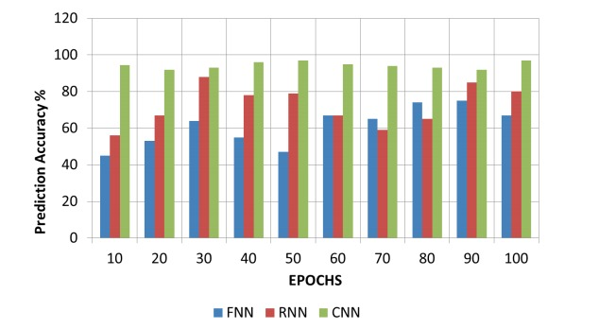

**FIGURE 7.2.A PERFORMANCE GRAPH ON VARIOUS CLASSIFIERS**

In Table 7.2.B, Table 7.2.B represents the accuracy we got by using CNN is better when compared to other neural networks like FNN and RNN. For CNN, the precision(ratio of correctly predicted positive observations) is 95%, F1 score(weighted average of precision and recall) is 0.7654, recall(how good the model at picking correct items) is 0.4567, true positive is 0.775 and false positive is 0.7856.

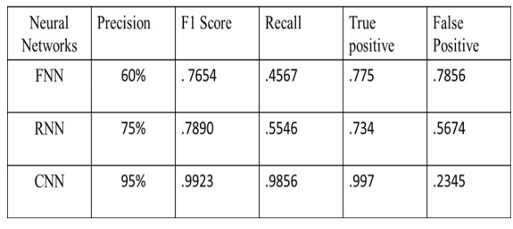

**FIGURE 7.2.B EVALUATION METRICS ON VARIOUS NEURAL NETWORKS**

Therefore, the performance analysed here is the performance accuracy for the training of the model is working better in CNN with used MRI images when compared to other neural networks like FNN and RNN.

**CHAPTER 8**

**CONCLUSION**

**8.1 CONCLUSION AND FUTURE ENHANCEMENTS**

In this project, we have proposed a recommender system which helps physicians to detect the presence and location of tumour.In this recommender system, a deep learning algorithm have been used called CNN which is the best algorithm for image recognition,since this system takes input in image format i.e JPEG or jpg . Initially,image processing techniques are done by taking  input MR image for enhancement of image quality and to detect and classify MR image into benign and malignant using a proposed CNN algorithm for accurate detection of brain tumor and giving treatment suggestions based on needs. By using this methodology, we improve the efficiency of detection and classification of brain tumors via MR Images.For physicians, it works like an add on, which reduces their work and time.

In future, further additional functionalities as per requirements will be added which includes automated expert system by using a advanced algorithms based on future developing technologies to excavate the deep information of brain in the process of brain abnormal detection in more accuracy upto 100% based on upcoming algorithms in future so that a better pre-planning treatment also can be suggested to prevent growing other abnormal tissues in brain at early stage itself if any abnormal tissues are likely seems to grow in brain. Our proposed system will suggest treatments only after detecting tumors in the brain based on needs and also our project is designed only to detect a tumor in the brain and giving treatment suggestions after the detection of tumor in brain.

**APPENDICES**

**A.1 SAMPLE SCREENS SHOTS**

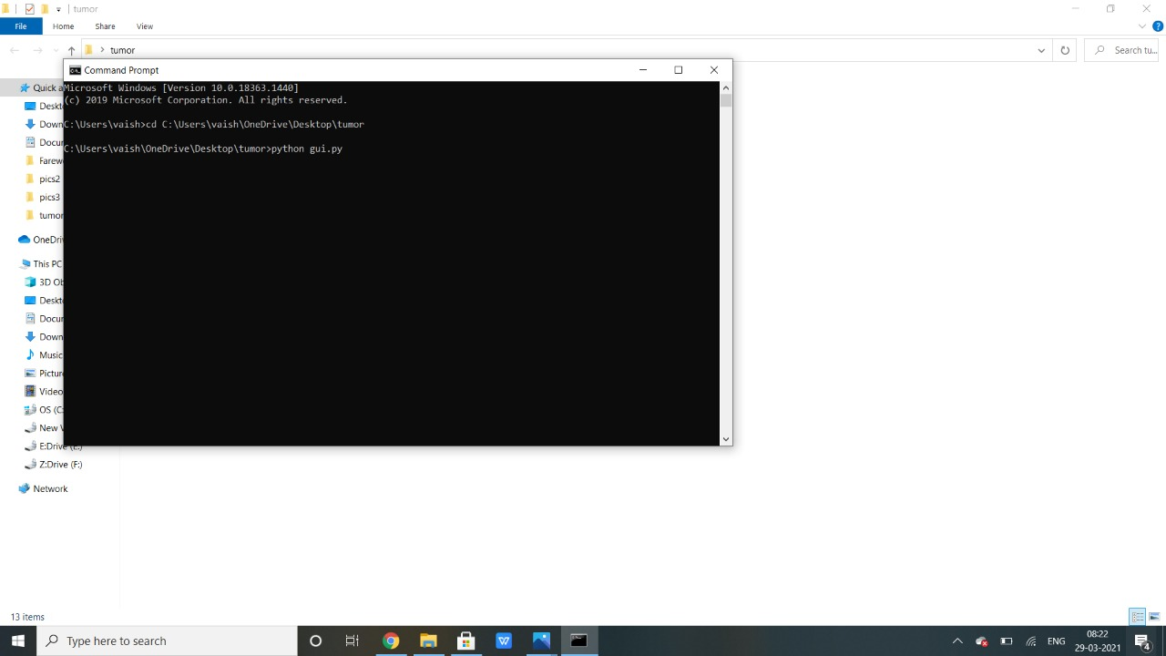**FIGURE A.1.1 OPENING COMMAND PROMPT WINDOW**

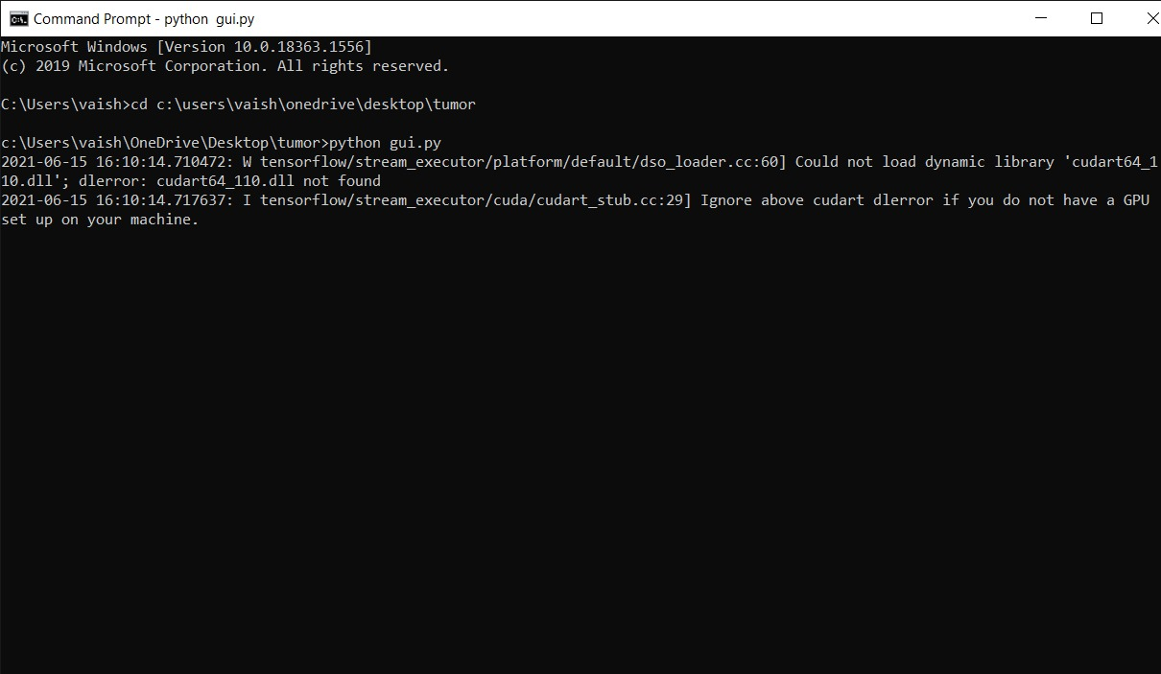**FIGURE A.1.2 TYPE THE PATH IN CMD TO OPEN DEMO PAGE**

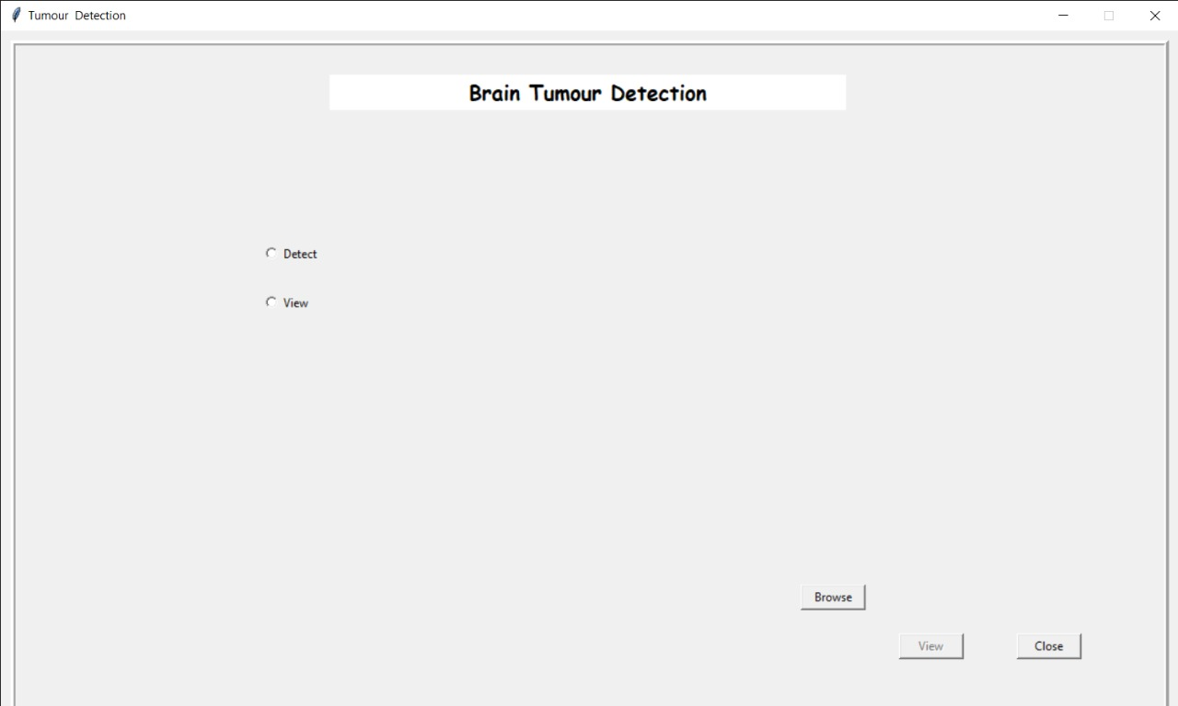**FIGURE A.1.3 OPENED DEMO PAGE AND CLICK BROWSE BUTTON**

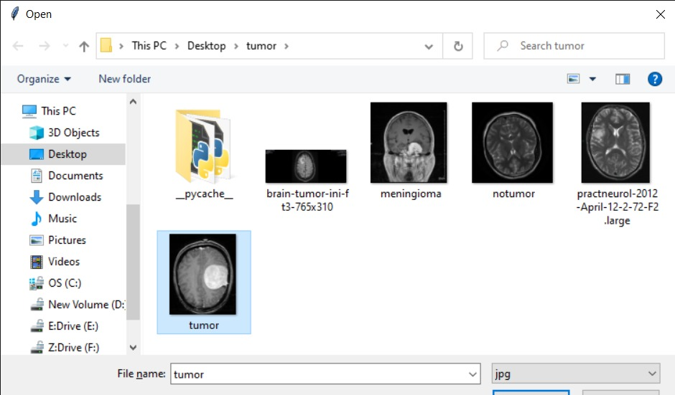**FIGURE A.1.4 SELECTING ANY ONE OF THE MRI BRAIN IMAGE**

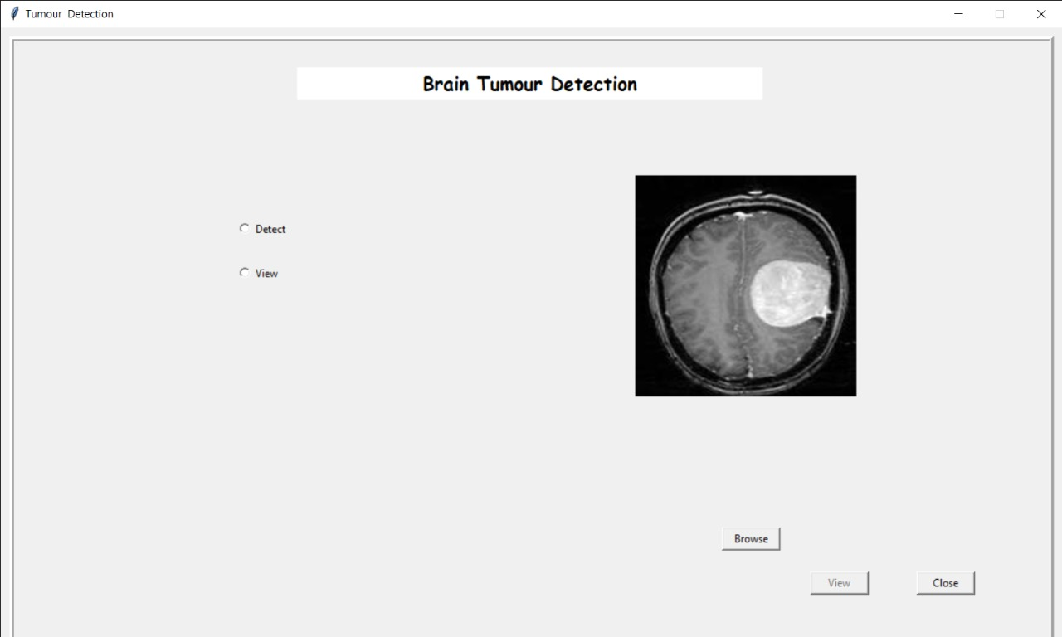**FIGURE A.1.5 UPLOAD THE SELECTED MRI BRAIN IMAGE**

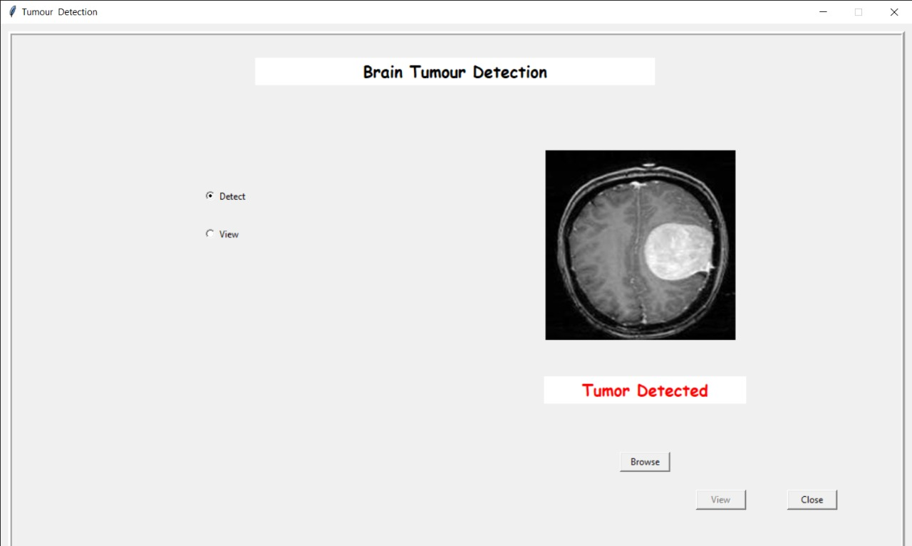 **FIGURE A.1.6 CLICK DETECT TO DETECT TUMOR IN BRAIN (TUMOR DETECTED IMAGE)**

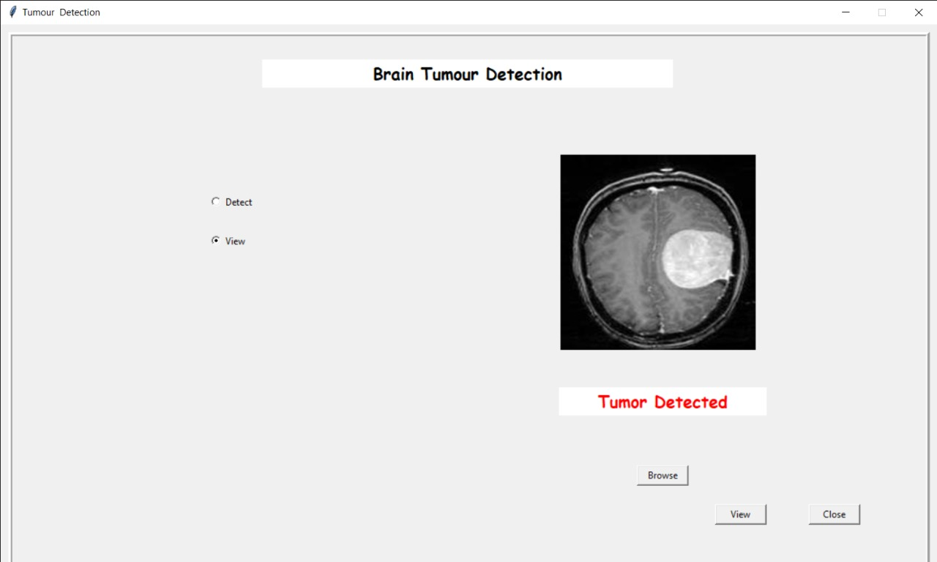**FIGURE A.1.7 CLICK VIEW TO SEE THE TUMOUR**

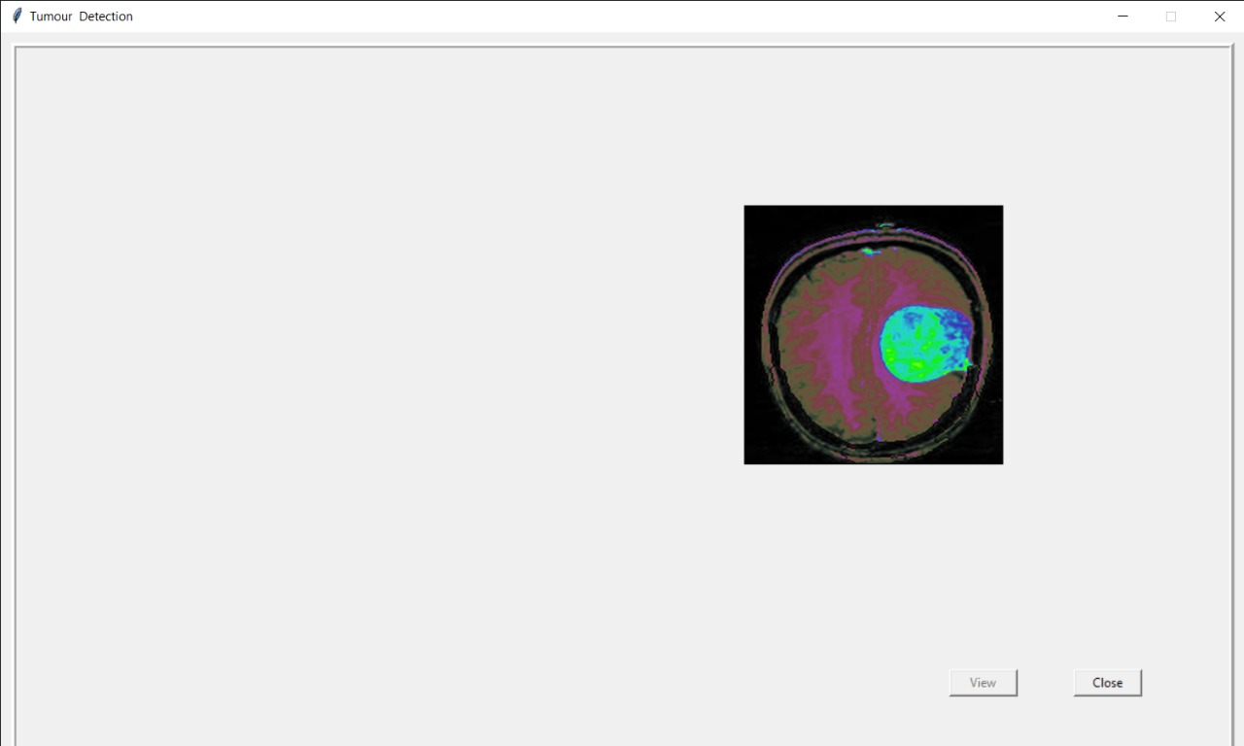**FIGURE A.1.8 SEGMENTED BRAIN TUMOUR**

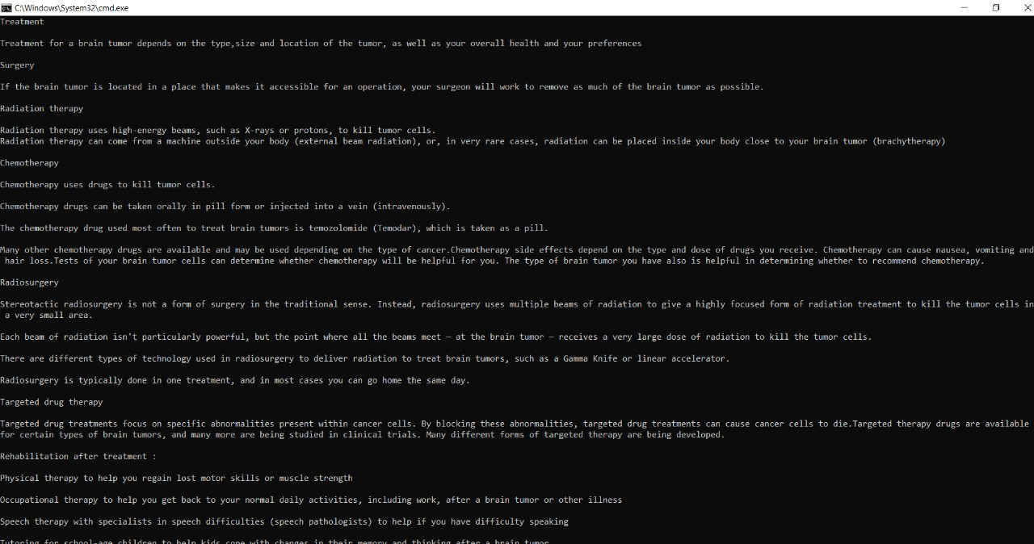**FIGURE A.1.9 TREATMENT SUGGESTION**

**A.2 PUBLICATIONS**

**Journal Name :** International Journal of Creative Research Thoughts (IJCRT)

**Paper Title :** Artificial Intelligence Recommendation System For Cancer Rehabilitation Scheme

**Published in :** Volume 9 | Issue 5 | May 2021







**A.2.1 PUBLISHED JOURNAL PAPER SCREENSHOTS**

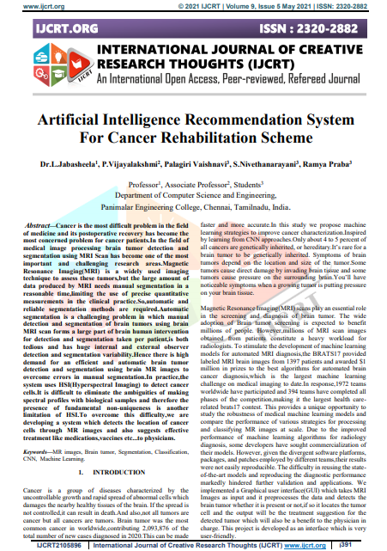

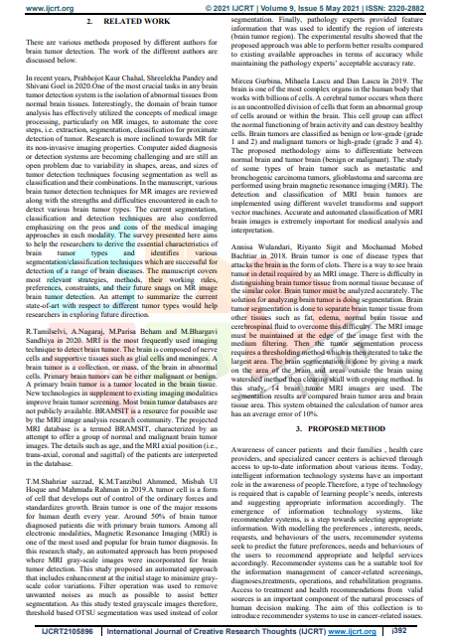

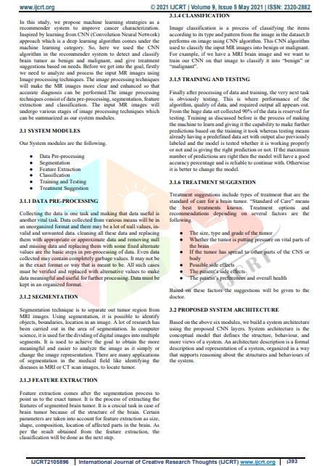

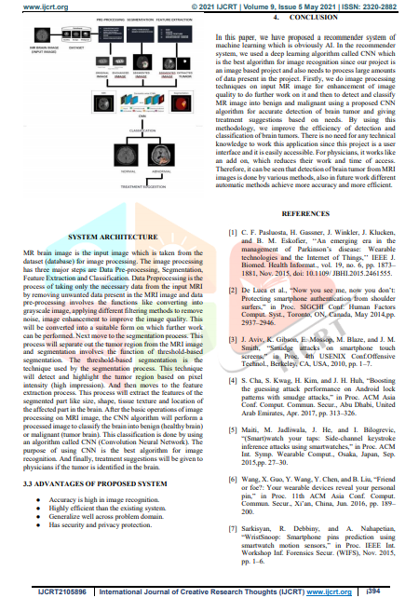

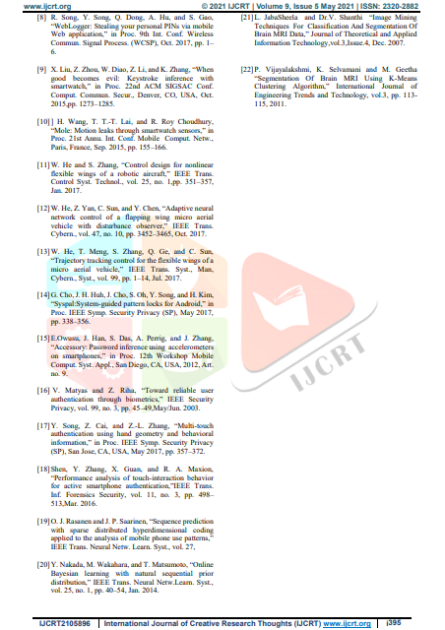

**REFERENCES**

1. C. F. Pasluosta, H. Gassner, J. Winkler, J. Klucken, and B. M. Eskofier, ‘‘An emerging era in the management of Parkinson’s disease: Wearable technologies and the Internet of Things,’’ IEEE J. Biomed. Health Informat., vol. 19, no. 6, pp. 1873–1881, Nov. 2015, doi: 10.1109/ JBHI.2015.2461555.

1. De Luca et al., “Now you see me, now you don’t: Protecting smartphone authentication from shoulder surfers,” in Proc. SIGCHI Conf. Human Factors Comput. Syst., Toronto, ON, Canada, May 2014,pp. 2937–2946.
2. J. Aviv, K. Gibson, E. Mossop, M. Blaze, and J. M. Smith, “Smudge attacks on smartphone touch screens,” in Proc. 4th USENIX Conf.Offensive Technol., Berkeley, CA, USA, 2010, pp. 1–7.
3. S. Cha, S. Kwag, H. Kim, and J. H. Huh, “Boosting the guessing attack performance on Android lock patterns with smudge attacks,” in Proc. ACM Asia Conf. Comput. Commun. Secur., Abu Dhabi, United Arab Emirates, Apr. 2017, pp. 313–326.
4. Maiti, M. Jadliwala, J. He, and I. Bilogrevic, “(Smart)watch your taps: Side-channel keystroke inference attacks using smartwatches,” in Proc. ACM Int. Symp. Wearable Comput., Osaka, Japan, Sep. 2015,pp. 27–30.
5. Wang, X. Guo, Y. Wang, Y. Chen, and B. Liu, “Friend or foe?: Your wearable devices reveal your personal pin,” in Proc. 11th ACM Asia Conf. Comput. Commun. Secur., Xi’an, China, Jun. 2016, pp. 189–200.
6. Sarkisyan, R. Debbiny, and A. Nahapetian, “WristSnoop: Smartphone pins prediction using smartwatch motion sensors,” in Proc. IEEE Int. Workshop Inf. Forensics Secur. (WIFS), Nov. 2015, pp. 1–6.
7. R. Song, Y. Song, Q. Dong, A. Hu, and S. Gao, “WebLogger: Stealing your personal PINs via mobile Web application,” in Proc. 9th Int. Conf. Wireless Commun. Signal Process. (WCSP), Oct. 2017, pp. 1–6.
8. X. Liu, Z. Zhou, W. Diao, Z. Li, and K. Zhang, “When good becomes evil: Keystroke inference with smartwatch,” in Proc. 22nd ACM SIGSAC Conf. Comput. Commun. Secur., Denver, CO, USA, Oct. 2015,pp. 1273–1285.
9. H. Wang, T. T.-T. Lai, and R. Roy Choudhury, “Mole: Motion leaks through smartwatch sensors,” in Proc. 21st Annu. Int. Conf. Mobile Comput. Netw., Paris, France, Sep. 2015, pp. 155–166.
10. W. He and S. Zhang, “Control design for nonlinear flexible wings of a robotic aircraft,” IEEE Trans. Control Syst. Technol., vol. 25, no. 1,pp. 351–357, Jan. 2017.
11. W. He, Z. Yan, C. Sun, and Y. Chen, “Adaptive neural network control of a flapping wing micro aerial vehicle with disturbance observer,” IEEE Trans. Cybern., vol. 47, no. 10, pp. 3452–3465, Oct. 2017.
12. W. He, T. Meng, S. Zhang, Q. Ge, and C. Sun, “Trajectory tracking control for the flexible wings of a micro aerial vehicle,” IEEE Trans. Syst., Man, Cybern., Syst., vol. 99, pp. 1–14, Jul. 2017.
13. G. Cho, J. H. Huh, J. Cho, S. Oh, Y. Song, and H. Kim, “Syspal:System-guided pattern locks for Android,” in Proc. IEEE Symp. Security Privacy (SP), May 2017, pp. 338–356.
14. E.Owusu, J. Han, S. Das, A. Perrig, and J. Zhang, “Accessory: Password inference using accelerometers on smartphones,” in Proc. 12th Workshop Mobile Comput. Syst. Appl., San Diego, CA, USA, 2012, Art. no. 9.
15. V. Matyas and Z. Riha, “Toward reliable user authentication through biometrics,” IEEE Security Privacy, vol. 99, no. 3, pp. 45–49,May/Jun. 2003.
16. Y. Song, Z. Cai, and Z.-L. Zhang, “Multi-touch authentication using hand geometry and behavioral information,” in Proc. IEEE Symp. Security Privacy (SP), San Jose, CA, USA, May 2017, pp. 357–372.
17. Shen, Y. Zhang, X. Guan, and R. A. Maxion, “Performance analysis of touch-interaction behavior for active smartphone authentication,”IEEE Trans. Inf. Forensics Security, vol. 11, no. 3, pp. 498–513,Mar. 2016.
18. O. J. Rasanen and J. P. Saarinen, “Sequence prediction with sparse distributed hyperdimensional coding applied to the analysis of mobile phone use patterns,” IEEE Trans. Neural Netw. Learn. Syst., vol. 27,
19. Y. Nakada, M. Wakahara, and T. Matsumoto, “Online Bayesian learning with natural sequential prior distribution,” IEEE Trans. Neural Netw.Learn. Syst., vol. 25, no. 1, pp. 40–54, Jan. 2014.

1. L. JabaSheela and Dr.V. Shanthi “Image Mining Techniques For Classification And Segmentation Of Brain MRI Data,” Journal of Theoretical and Applied Information Technology,vol.3,Issue.4, Dec. 2007.
2. P. Vijayalakshmi, K. Selvamani and M. Geetha “Segmentation Of Brain MRI Using K-Means Clustering Algorithm,” International Journal of Engineering Trends and Technology, vol.3, pp. 113-115, 2011.